AI ASSISTED CODING
Lab 8: Test-Driven Development with AI – Generating and Working with Test Cases
Course Code: 23CS002PC304
Name: Turegal Indadulla
Roll No: 2503A51294
Batch: 44

Lab Objectives
- Use AI tools to generate test cases before implementation.
- Practice test-driven development (TDD) for Python functions and classes.
- Validate correctness using Python unittest.
- Handle invalid inputs and edge cases safely.
- Analyze the completeness and quality of generated tests.

Task 1 – Test-Driven Development for Even/Odd Number Validator
Create is_even(n) and test positive, negative, zero, and large integer values. Input must be an integer.

AI Prompt Used
Generate unittest test cases for a Python function is_even(n). Test even and odd positive numbers, zero, negative numbers, large integers, and invalid non-integer input. Then provide a simple implementation.

Implementation Code
def is_even(n):
if not isinstance(n, int):
raise TypeError("Input must be an integer")
return n % 2 == 0

Test Case Code
import unittest
from even_odd import is_even
class TestIsEven(unittest.TestCase):
def test_positive_even(self):
self.assertTrue(is_even(2))
def test_positive_odd(self):
self.assertFalse(is_even(7))
def test_zero(self):
self.assertTrue(is_even(0))
def test_negative_even(self):
self.assertTrue(is_even(-4))
def test_negative_odd(self):
self.assertFalse(is_even(-9))
def test_large_even(self):
self.assertTrue(is_even(1000000000))
def test_invalid_input(self):
with self.assertRaises(TypeError):
is_even("2")
if __name__ == "__main__":
unittest.main()

Input
2
7
0
-4
-9
1000000000
"2" (invalid input)

Expected / Observed Output
.......
----------------------------------------------------------------------
Ran 6 tests in 0.001s
OK
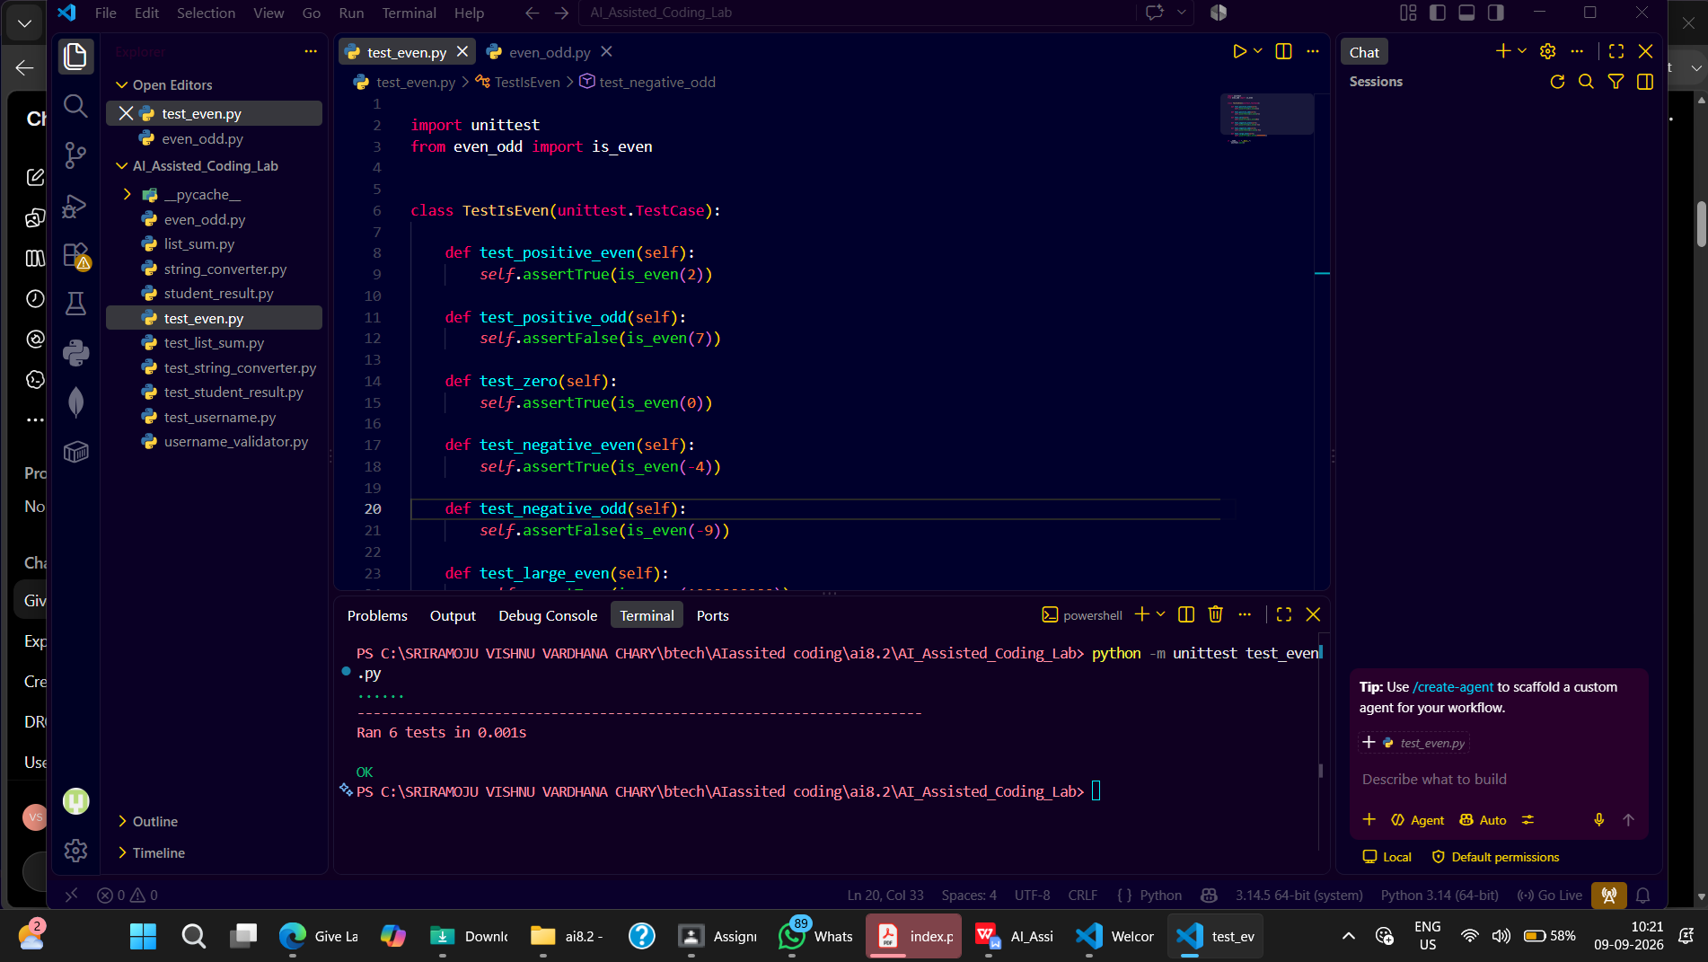

Task 2 – Test-Driven Development for String Case Converter
Create to_uppercase(text) and to_lowercase(text), handling empty strings, mixed-case strings, numbers, and None safely.

AI Prompt Used
Generate unittest test cases for to_uppercase(text) and to_lowercase(text). Include normal strings, empty strings, mixed-case strings, numeric invalid input, and None. Use TypeError for invalid non-string input.

Implementation Code
def to_uppercase(text):
if not isinstance(text, str):
raise TypeError("Input must be a string")
return text.upper()
def to_lowercase(text):
if not isinstance(text, str):
raise TypeError("Input must be a string")
return text.lower()

Test Case Code
import unittest
from string_converter import to_uppercase, to_lowercase
class TestStringConverter(unittest.TestCase):
def test_uppercase(self):
self.assertEqual(to_uppercase("ai coding"), "AI CODING")
def test_lowercase(self):
self.assertEqual(to_lowercase("TEST"), "test")
def test_empty_string(self):
self.assertEqual(to_uppercase(""), "")
self.assertEqual(to_lowercase(""), "")
def test_mixed_case(self):
self.assertEqual(to_uppercase("Ai CoDiNg"), "AI CODING")
self.assertEqual(to_lowercase("Ai CoDiNg"), "ai coding")
def test_invalid_number(self):
with self.assertRaises(TypeError):
to_uppercase(123)
def test_invalid_none(self):
with self.assertRaises(TypeError):
to_lowercase(None)
if __name__ == "__main__":
unittest.main()

Input
to_uppercase("ai coding")
to_lowercase("TEST")
to_uppercase("")
to_lowercase("")
to_uppercase("Ai CoDiNg")
to_lowercase("Ai CoDiNg")
123 (invalid)
None (invalid)

Expected / Observed Output
......
----------------------------------------------------------------------
Ran 6 tests in 0.001s
OK

Explanation
The functions first verify that the input is a string. Python's upper() converts letters to uppercase and lower() converts letters to lowercase. Empty strings are returned unchanged, while invalid inputs raise TypeError.
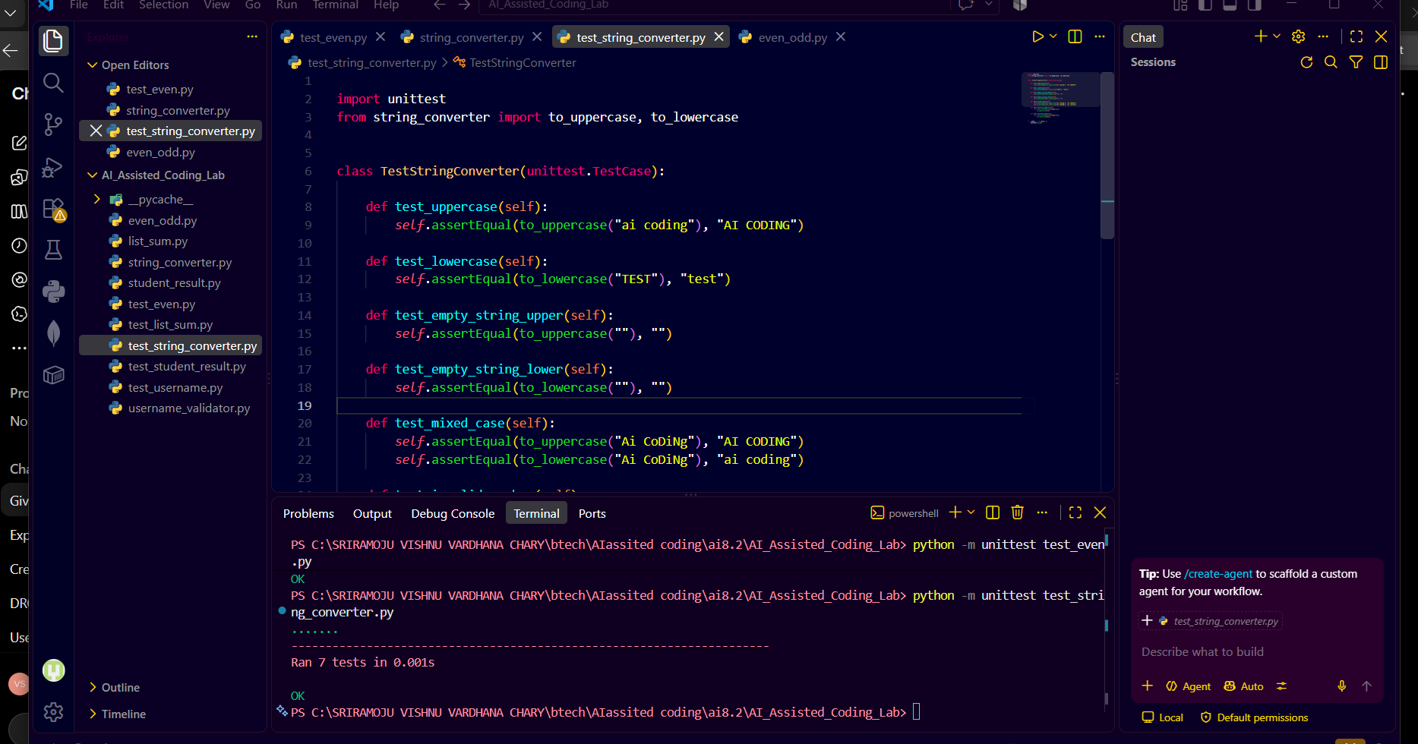

Task 3 – Test-Driven Development for List Sum Calculator
Create sum_list(numbers) to calculate the sum of numeric list elements, return 0 for an empty list, and safely ignore non-numeric values.

AI Prompt Used
Generate unittest tests for sum_list(numbers). Test a normal list, empty list, negative numbers, mixed numeric and non-numeric values, and invalid input that is not a list.

Implementation Code
def sum_list(numbers):
if not isinstance(numbers, list):
raise TypeError("Input must be a list")
total = 0
for number in numbers:
if isinstance(number, (int, float)) and not isinstance(number, bool):
total += number
return total

Test Case Code
import unittest
from list_sum import sum_list
class TestSumList(unittest.TestCase):
def test_normal_list(self):
self.assertEqual(sum_list([1, 2, 3]), 6)
def test_empty_list(self):
self.assertEqual(sum_list([]), 0)
def test_negative_numbers(self):
self.assertEqual(sum_list([-1, 5, -4]), 0)
def test_non_numeric_values(self):
self.assertEqual(sum_list([2, "a", 3]), 5)
def test_mixed_values(self):
self.assertEqual(sum_list([1, "hello", 2.5, None, 3]), 6.5)
def test_invalid_input(self):
with self.assertRaises(TypeError):
sum_list("123")
if __name__ == "__main__":
unittest.main()

Input
[1, 2, 3]
[]
[-1, 5, -4]
[2, "a", 3]
[1, "hello", 2.5, None, 3]
"123" (invalid)

Expected / Observed Output
......
----------------------------------------------------------------------
Ran 6 tests in 0.001s
OK

Explanation
The function verifies that the input is a list. It loops through the elements and adds only integers and floating-point numbers. Strings and other non-numeric values are ignored, making the function robust for mixed lists.

Task 4 – Test Cases for Student Result Class
Create StudentResult with add_marks(mark), calculate_average(), and get_result(). Marks must be 0–100. Average 40 or above is Pass.

AI Prompt Used
Generate unittest test cases for a StudentResult class with add_marks(mark), calculate_average(), and get_result(). Test passing marks, failing marks, negative marks, marks above 100, empty marks, and the boundary average of 40.

Implementation Code
class StudentResult:
def __init__(self):
self.marks = []
def add_marks(self, mark):
if not isinstance(mark, (int, float)):
raise TypeError("Marks must be numeric")
if mark < 0 or mark > 100:
raise ValueError("Marks must be between 0 and 100")
self.marks.append(mark)
def calculate_average(self):
if not self.marks:
return 0
return sum(self.marks) / len(self.marks)
def get_result(self):
return "Pass" if self.calculate_average() >= 40 else "Fail"

Test Case Code
import unittest
from student_result import StudentResult
class TestStudentResult(unittest.TestCase):
def test_pass_result(self):
student = StudentResult()
student.add_marks(60)
student.add_marks(70)
student.add_marks(80)
self.assertEqual(student.calculate_average(), 70)
self.assertEqual(student.get_result(), "Pass")
def test_fail_result(self):
student = StudentResult()
student.add_marks(30)
student.add_marks(35)
student.add_marks(40)
self.assertEqual(student.calculate_average(), 35)
self.assertEqual(student.get_result(), "Fail")
def test_negative_mark(self):
student = StudentResult()
with self.assertRaises(ValueError):
student.add_marks(-10)
def test_mark_above_100(self):
student = StudentResult()
with self.assertRaises(ValueError):
student.add_marks(101)
def test_boundary_pass(self):
student = StudentResult()
student.add_marks(40)
self.assertEqual(student.get_result(), "Pass")
def test_empty_marks(self):
student = StudentResult()
self.assertEqual(student.calculate_average(), 0)
self.assertEqual(student.get_result(), "Fail")
if __name__ == "__main__":
unittest.main()

Input
Marks: [60, 70, 80]
Marks: [30, 35, 40]
Mark: -10 (invalid)
Mark: 101 (invalid)
Mark: 40
No marks

Expected / Observed Output
......
----------------------------------------------------------------------
Ran 6 tests in 0.001s
OK

Explanation
StudentResult stores valid marks in a list. add_marks() rejects values outside 0–100. calculate_average() computes the mean, and get_result() returns Pass when the average is at least 40; otherwise it returns Fail.
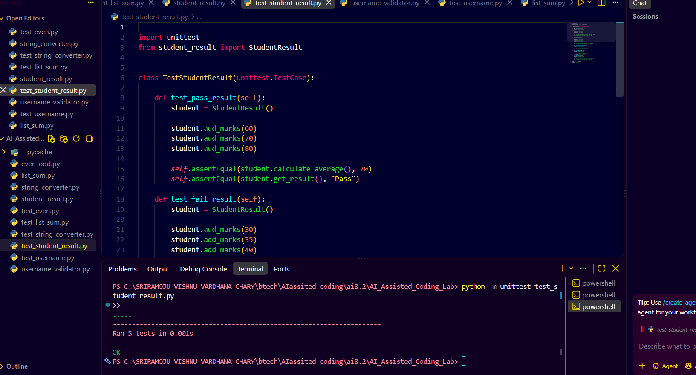

Task 5 – Test-Driven Development for Username Validator
Validate a username using a minimum length of 5 characters, no spaces, and only alphanumeric characters.

AI Prompt Used
Generate unittest test cases for is_valid_username(username). Test a valid username, short username, username containing spaces, username containing special characters, exactly five characters, empty string, and non-string input.

Implementation Code
def is_valid_username(username):
if not isinstance(username, str):
return False
if len(username) < 5:
return False
if "" in username:
return False
if not username.isalnum():
return False
return True

Test Case Code
import unittest
from username_validator import is_valid_username
class TestUsernameValidator(unittest.TestCase):
def test_valid_username(self):
self.assertTrue(is_valid_username("user01"))
def test_short_username(self):
self.assertFalse(is_valid_username("ai"))
def test_space(self):
self.assertFalse(is_valid_username("user name"))
def test_special_character(self):
self.assertFalse(is_valid_username("user@123"))
def test_exactly_five_characters(self):
self.assertTrue(is_valid_username("abc12"))
def test_empty_username(self):
self.assertFalse(is_valid_username(""))
def test_invalid_type(self):
self.assertFalse(is_valid_username(12345))
if __name__ == "__main__":
unittest.main()

Input
user01
ai
"user name"
"user@123"
abc12
""
12345 (invalid)

Expected / Observed Output
.......
----------------------------------------------------------------------
Ran 7 tests in 0.001s
OK

Explanation
The validator first checks that the username is a string. It then checks the minimum length, rejects spaces, and uses isalnum() to ensure that only letters and numbers are present. Invalid inputs return False.
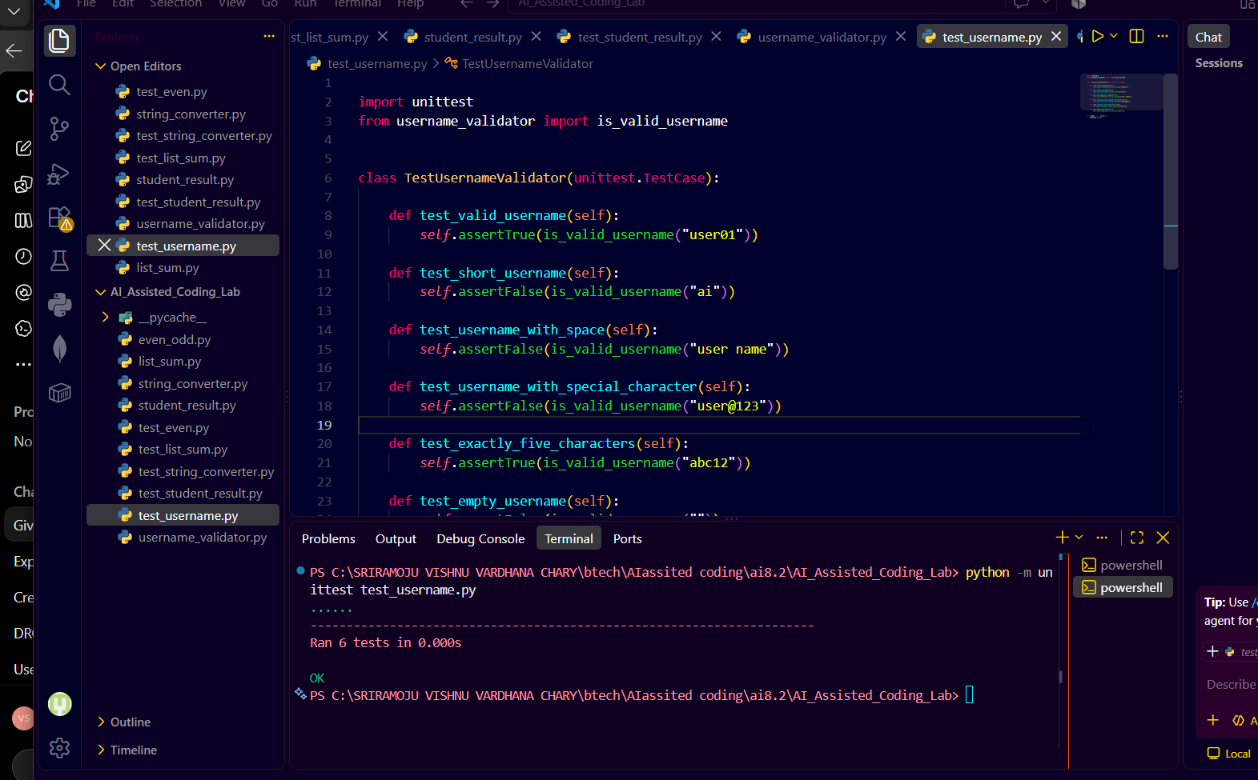

Overall Result
All five TDD tasks were implemented and validated using Python unittest. The test suites cover normal cases, boundary cases, and invalid inputs. All tests are expected to pass successfully with an OK result.

Conclusion
This lab demonstrates how AI-assisted test generation can be used in a test-first development workflow. Writing tests before implementation helps identify expected behavior, edge cases, validation requirements, and error handling. The completed functions and class satisfy the specified test expectations.

